**Sunnara Ruet**

**WDD 130**

**Whitewater Rafting Site Plan**

1. **Logo:**

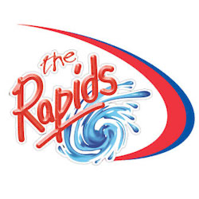

1. **Color Schema**

Four color labels:

* Primary-color: #769047
* Secondary-color: #97a7b5
* Accent1-color: #d8d8b9
* Accent2-color: #858284

1. **Typography**

Two font labels:

* Heading-font: Montserrat
* Text-font: Open Sans

1. **Color palette url**

<https://coolors.co/palette/d8d8b9-858284-97a7b5-769047>